**DAILY ONLINE ACTIVITIES SUMMARY**

|  |  |  |  |  |  |  |  |  |
| --- | --- | --- | --- | --- | --- | --- | --- | --- |
| **Date:** | **21-06-2020** | | | | | **Name:** | **Anusha** | |
| **Sem & Sec** | **VIII Semester & A Section** | | | | | **USN:** | **4AL16CS014** | |
| **Online Test Summary** | | | | | | | | |
| **Subject** | | **No Test** | | | | | | |
| **Max. Marks** | | **-** | | **Score** | | | **-** | |
| **Certification Course Summary** | | | | | | | | |
| **Course** | **Introduction to EC2 Auto Scaling** | | | | | | | |
| **Certificate Provider** | | | **Amazon Web Service** | | **Duration** | | | **10 minutes** |
| **Coding Challenges** | | | | | | | | |
| **Problem Statement: Write a program for matrix boundary** | | | | | | | | |
| **Status: COMPLETED** | | | | | | | | |
| **Uploaded the report in Github** | | | | | **YES** | | | |
| **If yes Repository name** | | | | | **anushasuvarna-014** | | | |
| **Uploaded the report in slack** | | | | | **YES** | | | |

Online Test Details:

NIL

Certification Course 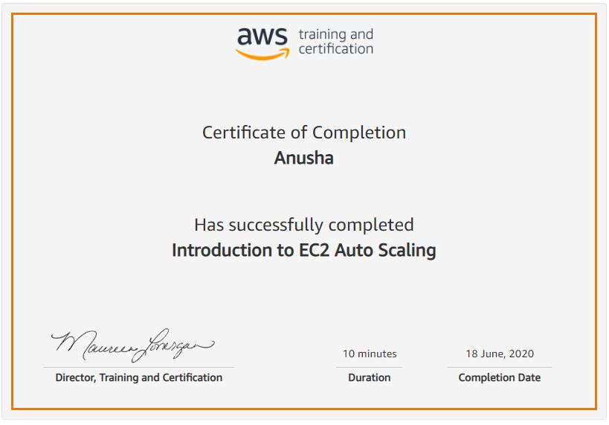

Coding Challenges Details:

**Program:**

|  |
| --- |
| #include<stdio.h> |
|  |  |
|  | void main() |
|  | { |
|  | int arr[10][10], i, j, m, n, sum = 0; |
|  |  |
|  | printf("Enter M rows and N columns: "); |
|  | scanf("%d%d", &m, &n); |
|  |  |
|  | printf("Enter the elements:\n"); |
|  | for(i = 0; i < m; i++) |
|  | for(j = 0; j < n; j++) |
|  | scanf("%d", &arr[i][j]); |
|  |  |
|  | printf("The input matrix is:\n"); |
|  | for(i = 0; i < m; i++) |
|  | { |
|  | for(j = 0; j < n; j++) |
|  | printf("%d ", arr[i][j]); |
|  | printf("\n"); |
|  | } |
|  |  |
|  | printf("The boundary elements are: "); |
|  | for(j = 0; j < n; j++) |
|  | printf("%d ", arr[0][j]); |
|  | for(i = 1; i < m - 1; i++) |
|  | for(j = 0; j < n; j++) |
|  | { |
|  | if(j == 0 || j == n-1) |
|  | printf("%d ", arr[i][j]); |
|  | } |
|  | for(j = 0; j < n; j++) |
|  | printf("%d ", arr[m-1][j]); |
|  |  |
|  | for(j = 0; j < n; j++) |
|  | sum += arr[0][j]; |
|  | for(i = 1; i < m - 1; i++) |
|  | for(j = 0; j < n; j++) |
|  | { |
|  | if(j == 0 || j == n-1) |
|  | sum += arr[i][j]; |
|  | } |
|  | for(j = 0; j < n; j++) |
|  | sum += arr[m-1][j]; |
|  |  |
|  | printf("\nThe sum of boundary elements of the matrix is: %d\n", sum); |
|  | } |